
Deal Parochial Church of England (Aided) Primary School

Mrs M Palmer BA Honours, PGCE, NPQH Gladstone Road
Headteacher Walmer, Deal
Tel: 01304 374464 Kent CT14 7ER
email: secretary@deal-parochial.kent.sch.uk Website: www.deal-parochial.kent.sch.uk

Christian values: - Kindness, Trust, Friendship, Respect, Courage, Forgiveness
TO BE THE BEST THAT I CAN BE – THE WAY GOD INTENDS
Prayer for New Beginnings
Lord you make all things new, the Creator who is continually nurturing, renewing and developing every aspect of our remarkable universe.
Lord you make all things new. I rest in your creative arms, I dwell in the hope of this renewal, I hope in the strength of your mighty hand.
Lord you make all things new. Take all I am, all I care for and all I love into your gentle arms. Come to touch and heal, mend and restore, release and minister.
Lord thank you that you make all things new. Thank you that today my life is being remade anew.
Amen
Newsletter Term 1
What a great start to the term! There has been a real buzz of learning throughout the school and it has been lovely to see the children all looking so smart and happy to come to school each morning. A very special welcome to all of our new children in Reception and their families.
Thank you for making me feel so welcome as the new Headteacher of Deal Parochial Church of England Primary School and I look forward to getting to know you all over the coming weeks.

Curriculum news
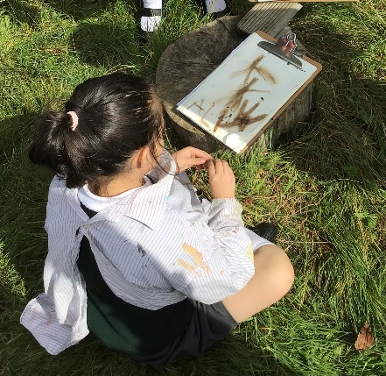
The first Art lesson in Year 3 linked to their History topic of the Stone Age… they were learning to draw and paint like the Stone Age people would have done. They looked at cave paintings and the techniques they would have used, then explored the forest school area and used what they could find to draw and paint a thoroughly fascinating and fun time was had by all!
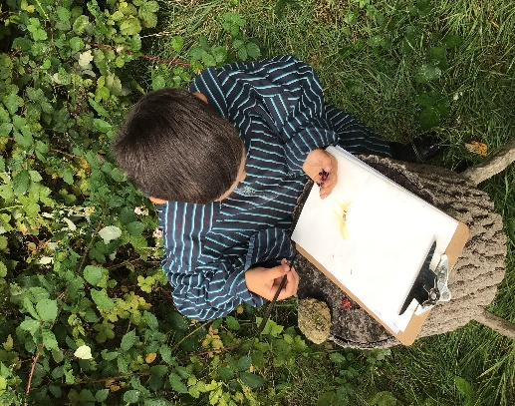

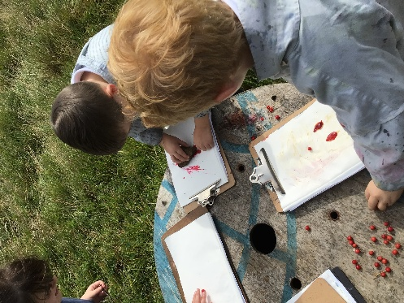

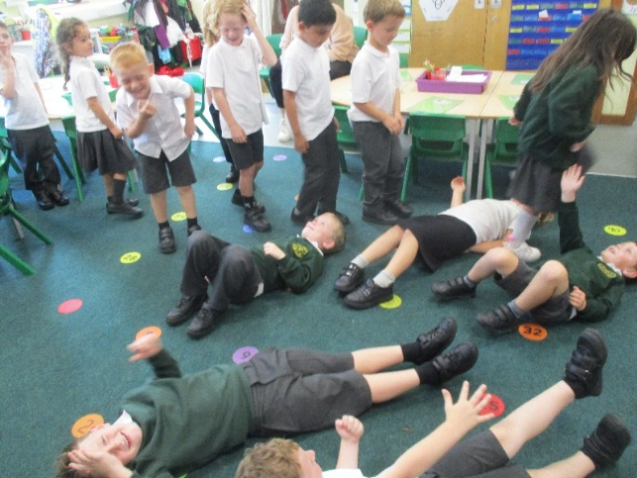
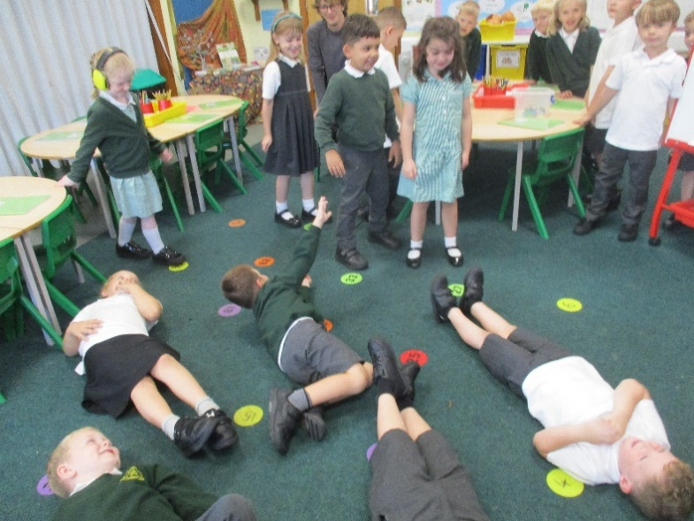
Year 1 have been using drama to re-tell the story of the Good Samaritan in their RE lessons. They shared the parable, thought about what the story was telling them about kindness and respect and then re-enacted their own versions.

School Uniform
Please ensure that your child’s belongings are named - they all look so smart and we don’t want them losing their jumpers, etc. We had a lot of children without coats last week and had a lot of very wet weather. As we approach the autumnal months please ensure that your child has a named coat in school.

PTFA Meeting Monday 15th September 3.30pm in the School Hall

In these difficult financial times, it is imperative that we work together to raise funds for the benefit of all our children in school. We need your support to do this. We are holding our first PTFA meeting next Monday and you are welcome to bring your children with you for a short meeting. This is to discuss the current budget, nominate positions on the committee, discuss some fundraising ideas and to see what collectively we can do to raise funds to support our children’s education. Whatever you can contribute, even a small amount of your time would be greatly appreciated. We promise refreshments, commitment and laughter - so please do come and join us.
Dates for your diary: Week beginning 15th September is meet the teacher week, an opportunity for you to meet your child’s new teacher and find out more about the year ahead:
Monday 15th September Years 1 and 2
Tuesday 16th September Year 5
Wednesday 17th September Year 6
Thursday 18th September Years 3 and Year 4
Harvest Festival 9th October 10-11am at St. Leonard’s Church for Years 1-6

