
Deal Parochial Church of England (Aided) Primary School

Mrs M Palmer BA Honours, PGCE, NPQH Gladstone Road
Headteacher Walmer, Deal
Tel: 01304 374464 Kent CT14 7ER
email: secretary@deal-parochial.kent.sch.uk Website: www.deal-parochial.kent.sch.uk

Christian values: - Kindness, Trust, Friendship, Respect, Courage, Forgiveness
TO BE THE BEST THAT I CAN BE – THE WAY GOD INTENDS
Newsletter 2 Term 1 22/9/2025

In our collective worship we have been reflecting on trust and loyalty and have been learning about the story of Naomi and Ruth:
¹⁶ But Ruth said, “Don’t ask me to leave you! Don’t beg me not to follow you! Every place you go, I will go. Every place you live, I will live. Your people will be my people. Your God will be my God. ¹⁷
Ruth 1: 16-17


Parking
Thank you so much for putting our children’s safety first and for taking care when using the drop off zone. We are so fortunate to have this facility and it will only work if we all continue to only use this as a drop off zone and not for parking. Please can we also ask that only those parents with disabled badges use the disabled parking bays and leave the disabled parking bay accessible at all times - do not park across these.
Thank you in advance for your support with this matter.

PTFA Meeting Today 3.30pm in the School Hall

Apologies that we had to move this date due to meet the teacher meetings. Please do come and join us in the hall today straight after school, your children can come along too!
Whatever you can contribute, even a small amount of your time would be greatly appreciated. We promise refreshments, commitment and laughter - so please do come and join

Meet the Teacher Week
It was lovely to see so many parents/carers attend these. It was a good opportunity to find out about your child’s next year ahead and to find out more about the curriculum and expectations. We want to continue to work in partnership with you for the benefit of your children, so please don’t hesitate to ask if you are unsure of anything or would like some re-assurance. Teachers are available to speak to at the end of each day or you can message on Class Dojo.

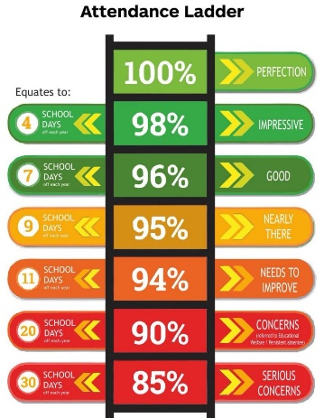
Attendance Update
Please ensure that your child is in school every day unless they are poorly. If you are unsure as to whether your child is poorly or not then send them into school and we will monitor and send them home if needed. Please see the following link for advice from the NHS.
Is my child too ill for school? - NHS

Preparing for the Autumnal weather

Please ensure that your child has a coat in school and brings in a pair of named wellies to change into for when the field becomes a lot wetter. This will enable the children to use all of our grounds during the autumn / winter months.

Curriculum news
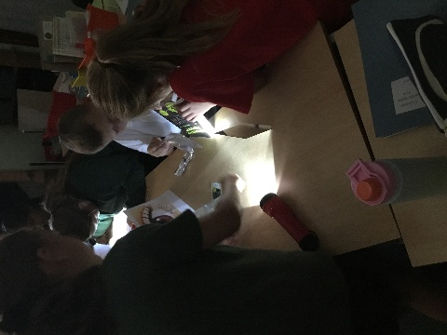
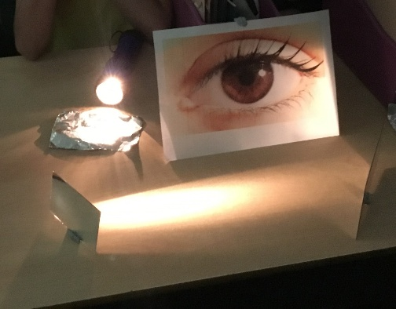
Year 6 carried out a science investigation for their topic on light. Their objective was to show that light travels in straight lines. To achieve this, the children had to use mirrors and other reflective materials (e.g. tin foil) to try and reflect light from the torch into the picture of the eye. They had to think carefully about where the reflective materials needed to be placed so the light would reflect in the desired direction.

Dates for your diary:
Year 4 out at Pizza Express in Canterbury Wednesday 24th September.
Harvest Festival – Thursday 9th October 10-11am at St. Leonard’s Church for Years 1-6
Hello Yellow Day - Friday 10th October- World Mental Health Day, wear a yellow item to support this event and raise money for Young minds
Friday 17th October last day of term

