
Deal Parochial Church of England (Aided) Primary School

Mrs M Palmer BA Honours, PGCE, NPQH Gladstone Road
Headteacher Walmer, Deal
Tel: 01304 374464 Kent CT14 7ER
email: secretary@deal-parochial.kent.sch.uk Website: www.deal-parochial.kent.sch.uk

Christian values: - Kindness, Trust, Friendship, Respect, Courage, Forgiveness
TO BE THE BEST THAT I CAN BE – THE WAY GOD INTENDS

Newsletter 3 Term 1
Harvest Celebration
In our collective worship this week we will be thinking about Harvest. We will be learning about why we celebrate harvest and how we can say thank you. On Thursday we will be having our Harvest celebration at St. Leonard’s Church for years 1-6 at 10am.
Parents and carers are welcome to come along for this special celebration.
We also need adult support to help to walk the children to the church, if you are able to help then please message your child’s teacher on Class Dojo. We will be leaving school at 9.15am on Thursday in order to get to the church for 10am.

Our chosen charity for Harvest
Please send your child into school with a packet or tin of food during this week. The last day for collection will be Friday. All proceeds will be going to Deal Foodbank. Thank you in advance for your contributions.
For further ideas for donations please see the following webpage:

https://dealarea.foodbank.org.uk/give-help/donate-food/

Preparing for the Autumnal weather/winter months
Please ensure that your child has a coat in school and brings in a pair of named wellies or old outdoor shoes to change into for when the field and grounds become muddy. This will enable the children to use all of our grounds during the autumn / winter months.

Curriculum news
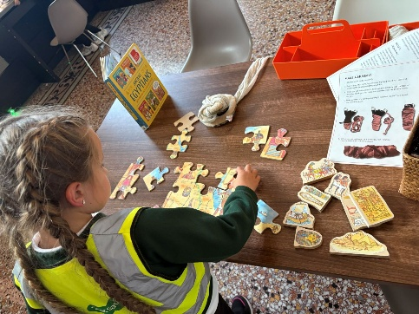
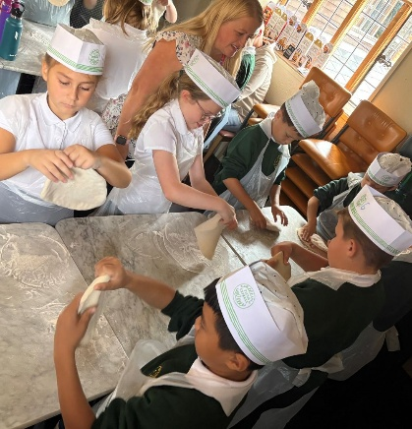
On Wednesday 24th September Year 4 visited Pizza Express in Canterbury and also the Beaney House of Art and Knowledge. They were able to make their own pizzas (some future chefs in the making seen!) and were also able to taste and learn about different foods. They then went to the Beaney Museum where they were able to handle different artefacts, learn about ways of life in earlier times including that of the Romans. They were able to look at different pieces of Art work and step into paintings where they could dress up as characters from some of these. They had an opportunity to look at some explorers’ treasures that have made it back to Canterbury; this included remarkable finds from the excavations of Ancient Egypt and Anglo-Saxon Kent, alongside Ancient Greek Art.

Hello Yellow Day Friday 10th October

Just a reminder that this Friday is Hello Yellow Day where all children and adults are invited to wear something yellow to show their support for World Mental Health day. We are raising money to support Young Minds - a charity to ensure that no young person feels alone and has someone to support them with their mental health. We are asking for a donation of £1 or more to support this charity.
For further information about Hello Yellow day please visit:

https://www.youngminds.org.uk/support-us/fundraising/stream-for-youngminds/

Tours available for Year R places in September 2026
If you are looking for a Reception school place for your child in September then please book a place on one of our tours. Applications open on November 7th and close on January 15th 2026. For further information about the application process visit:

https://www.kent.gov.uk/education-and-children/schools/school-places/primary-school-places

Dates for your diary:
Harvest Festival 9th October 10-11am at St. Leonard’s Church for Years 1-6
Hello Yellow Day Friday 10th October - World Mental Health Day, wear a yellow item to support this event and raise money for YoungMinds
Friday 17th October last day of term
Term 2 starts Wednesday 29th October
School Disco Thursday 30th October (further details to follow)
School Photos Monday 17th November
Parents’ Evening Week Beginning 10th November (sign up lists will go up the week before)
Friday 12th December 1.45pm Year 2 Nativity at St. Georges Church (further details to follow)

