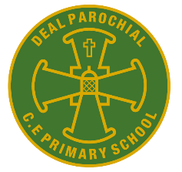
Deal Parochial Church of England (Aided) Primary School

Mrs M Palmer BA Honours, PGCE, NPQH Gladstone Road
Headteacher Walmer, Deal
Tel: 01304 374464 Kent CT14 7ER
email: secretary@deal-parochial.kent.sch.uk Website: www.deal-parochial.kent.sch.uk

Christian values: - Kindness, Trust, Friendship, Respect, Courage, Forgiveness
TO BE THE BEST THAT I CAN BE – THE WAY GOD INTENDS
Newsletter 2 Term 2


Remembrance Day 11th November
Last week we held a special remembrance worship to remember all those past and present who have given their lives for peace. The children also sang Make me a Channel of Your Peace which is based on the prayer of St. Francis. Thank you to Mrs. Blackman who with the children created a poppy display outside of school on our gates. Thank you also for all the money raised by children buying poppies- all proceeds go towards the British Legion.

Anti- Bullying Week

Thank you for supporting the Odd Socks Day - this helped the children understand that while we are all different, we share common humanity. It reminded them that everyone is unique and to celebrate diversity. We discussed the Power for Good and the importance of being brave, being kind and to stand up for what is right. We also linked this to our new school rules:
Be Safe, Be Ready, Be Kind.

Children in Need
We’re delighted to share that we raised nearly £200 — thank you for your generous support! Your contributions will help improve the lives of children of all ages across the UK.

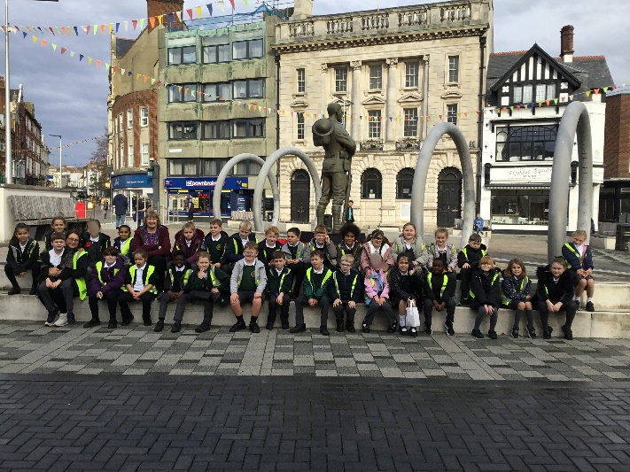
Curriculum news
On Thursday 6th November, Year 3 went to the Dover Museum. The fun began by learning how to read the train times at the station before their exciting journey had begun. Once there, the class impressed Diana (the archaeologist) with their knowledge of the Stone, Bronze and Iron ages as she took them on a whistle-stop tour of half a million years of history. They took part in an artefact investigation - getting to handle real objects and use their skills to work out what they were used for. They then went up to see and learn about the amazing Bronze Age boat, found in Dover, and had a chance to investigate the pre-historic exhibitions. After lunch, the children learnt about the ice ages and got crafty by making their own mammoths. The museum staff commented on how polite, well-informed and interested our children were, as they were keeping the staff busy with lots of great questions! They were a credit to the school with their excellent behaviour, well done Year 3!

Year 4 had a special presentation about the design of Keel Toys
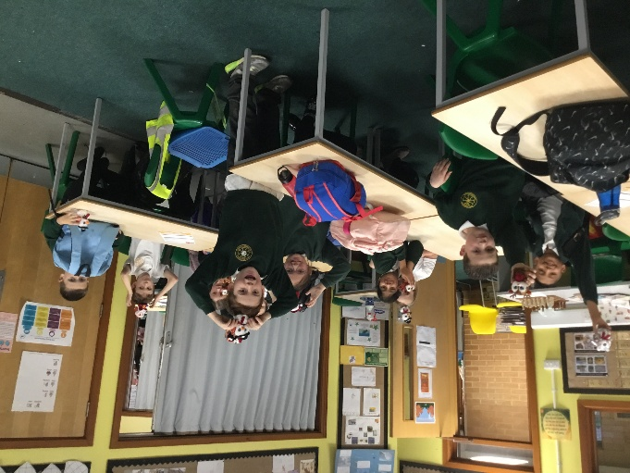
On Thursday 13th November, Year 4 were very lucky to receive a fabulous presentation from Patrick Downs (Zacchary's dad) about his job as 'Head of Design' for Keel Toys. This term, Year 4 are sewing Christmas stockings as part of their Design Technology topic so the journey from 'design to product' was a brilliant learning experience for us all. Patrick explained the process, identifying that designs are drawn, materials are carefully chosen and templates produced before it is joined with a carefully chosen stitch. Year 4 will follow a similar process in their learning. He showed the children a video which explained how the company uses recycled bottles to make their soft toys. Every child was then gifted a soft toy as a reminder of this great talk. A big thank you from Year 4! We look forward to welcoming Patrick back into school once our project is complete.

Attendance Matters
Regular school attendance is vital for your child’s learning, confidence, and wellbeing. We understand that children may occasionally be too unwell to attend — in those cases, rest and recovery at home are important. However, if you're ever unsure, please do send them in. We’ll always be in touch if we have any concerns during the day. For further information please visit:
https://www.nhs.uk/live-well/is-my-child-too-ill-for-school/

Tours available for Year R places in September 2026
Just a reminder that if you are looking for a Reception school place for your child in September then please book a place on one of our tours. Applications open on November 7th and close on January 15th 2026. For further information about the application process then visit
https://www.kent.gov.uk/education-and-children/schools/school-places/primary-school-places


Christmas Fair 5th December from 2.30pm
On this day we are offering an early pick up just before the Fair – if you are a working parent and can’t pick your child up at this time then we will keep your child until the normal time of 3.15pm. The choir will be performing, there will be Santa’s Grotto, hampers, a tombola, refreshments and fun and games! Please do come and support us. If you would like to help run a stall or help with refreshments then please contact Christine Knight at the school Office. Help us to raise funds for our school – we are hoping to raise money for new playground equipment and markings!
To support the fair there will be a non-uniform day next Friday 21st November for a hamper item (class teachers will contact you separately through Class Dojo). On Friday 28th November there will be a Non- Uniform Day for Tombola items: Year R red and gold or Christmas themed; Year 1 and 2 – toiletries; Year 3 biscuits; Year 4 – chocolate; Year 5 and 6 bottles. Any alcoholic drinks to be taken directly to the school office please. Thanks in advance for all of your support!

Good condition Old Toys needed for Playtime
If you are having a clear out of toy cupboards in readiness for Christmas we really would appreciate any of the following to top up our lunchtime play toys:
Toy cars
Barbie dolls / clothes or any dolls / clothes
Marvel figures or any superhero toys
Dinosaurs
Chalk
Playdough
Many thanks for your support - I know the Play Leaders will be so happy to have some extra toys to put out for the children.

Staff Leaving
We would like to inform you that Mrs. Roberts will be leaving us on 5th December. We are incredibly grateful for all she has done for the children over the past few years — her dedication, warmth, and support have made a lasting impact on our school community. We wish her every success and happiness in her new role at her new school. The school is currently advertising for a new Special Needs Assistant, and we hope to fill the position as soon as possible to ensure a smooth transition for the children.

Dates for your diary:
21st November – Non-uniform day for hamper items, (class teachers will contact you separately through Dojo)

28th November - Non-uniform day for Christmas Fair items Year R red and gold or Christmas themed; Year 1 and 2 – toiletries; Year 3 biscuits; Year 4 – chocolate; Year 5 and 6 bottles.

Friday 5th December, Christmas Fair from 2.30pm. Any donations of cakes would be appreciated on this day.

Thursday 11th December, Whole School to watch Sleeping Beauty pantomime at Goodwin Academy.
Friday 12th December, Nativity Service at St George’s Church at 1.45pm. Collection from the Church.
Tuesday 16th December, KS2 to watch Robin Hood pantomime at The Astor Theatre.
Wednesday 17th December, Christmas Lunch and Jumper Day.
Friday 19th December, Last Day of Term.

