
Deal Parochial Church of England (Aided) Primary School

Mrs M Palmer BA Honours, PGCE, NPQH Gladstone Road
Headteacher Walmer, Deal
Tel: 01304 374464 Kent CT14 7ER
email: secretary@deal-parochial.kent.sch.uk Website: www.deal-parochial.kent.sch.uk

Christian values: - Kindness, Trust, Friendship, Respect, Courage, Forgiveness
TO BE THE BEST THAT I CAN BE
Term 2 Newsletter 3
Advent

We have lit our third advent candle this week as we remember joy. Otherwise known as the Shepherd Candle, this candle reflects the joy that comes through Jesus’ arrival and through the salvation he has gifted us.

Christmas Fair Friday 5th December
A big thank you for all of your donations and for supporting this event. We raised £1700 which is an amazing amount of money that will go towards supporting our children in school with some additional resources for learning and for play. A big thank you to the PTA for all of the hours that they put in to preparing for this in order to make it such a success. A special shout out to the parents who helped especially Michelle Pickering – we couldn’t have done it without you.

Curriculum News – Year 4 Lantern Parade
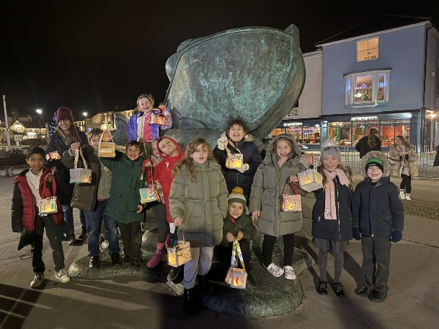
Last Wednesday Year 4 children made some lanterns with some volunteers from Samphire in readiness for a special parade. On Friday 12 December, Deal Pier was lit up with a beautiful lantern parade organised by local human rights charity Samphire in partnership with Deal Town Council and local school children; including some of our Year 4 children.
The event began at the entrance to the pier and those assembled were joined by Deal’s Mayor. The parade walked to the end of the pier where all were treated to a carol performance and sing along by the Deal Landmark Choir. And there were festive refreshments for the school children too.
Samphire have been working with local primary school children to learn about togetherness and welcome, and created beautiful painted lanterns to use in the procession.

Girls Football News!
Our Girls Football team have won the McCarthy cup with the final score being:
Deal Parochial 3 Temple Ewell 2
The girls displayed everything you could ever ask for in a football match, goals, tackles, resilience, determination, and teamwork. The first 10 minutes brought chances for our girls to score but they couldn't find a way to break the deadlock both teams battled but by halftime the score remained 0-0.
After the break and a team talk the girls got back out on the pitch and continued their impressive display at football, working as a team our girls had the most possession but within 5 minutes of the restart Temple Ewell took the lead. Mr. Earl reminded them to keep their heads up and dig deep to find an equaliser and sure enough excellent play between Emilie, Zavanna and Effie found Emilie in space to equalise.
Shortly after the restart Temple Ewell took the lead again only for Zavanna to equalise shortly after to make it 2-2. As the seconds were counting down to full time and penalties looming, smart play from our girls in defence through to Emilie, Zavanna and Effie who found the winning goal to win the game 3-2! Well done girls we are super proud of you all!

Breakfast Club & After School Provision
Just a reminder that Breakfast club will be open to children from 7.45am as from 6th January. Also, as previously indicated, there is a small price increase to £3.50 per day from term 3 due to the increase in running costs. To reserve a place, payment will need to be made simultaneously for both Breakfast and After School Provision. Please ensure your school money accounts have sufficient credit for you to pay for this service.

Panto at Goodwin Academy

Last Thursday, the whole school watched a performance of Sleeping Beauty performed by the students at the Goodwin Academy. The children joined in with the traditional Ghost Buster panto song and were a brilliant audience. The students at Goodwin Academy did a brilliant job with the acting, singing and dancing. Our children thoroughly enjoyed themselves and Goodwin commented on what a great audience they were. Well done children!

Basketball at Dover Christchurch Academy

Representatives from Year 5 and 6 children took part in the Basketball event at Dover Christchurch Academy on Thursday 4th December. Deal Parochial played 8 games in total against 7 schools from Dover. Deal Parochial won 5 and drew 3 games which is a fantastic achievement for these pupils they worked tirelessly together. Well done to all those who took part. Great sportsmanship and respect to each other seen and towards the opposition.

A reminder about School Uniform

Please can I remind everyone that on PE days children can wear school PE kit – no branded items please. PE school uniform should be plain black jogging bottoms, a house team T shirt and a plain black sweatshirt, school fleece or a school jumper. We have plenty of spare items should your child be missing any of these.

Nativity Service at St George’s Church
What a festive treat we all had on Friday! Year 2 did a fantastic nativity; their singing and acting was just amazing as they told the Christmas story through the eyes of the animals in the stable. They demonstrated such courage performing in front of such a large audience and were so supportive of each other. Many thanks to Miss. Dowling and her Year 2 team for putting this together. Our school band made up of Eva, George, Molly and Emily in Year 6 were great as they supported Mr. Greenhalgh to play the music. A special shout out to Molly who led us all with Once in Royal David’s City and also to our choir who sang beautifully as well.

On behalf of all the staff and governors, we wish you all a very Happy Christmas and a Joyous New Year. Have a very special time celebrating with friends and family. We look forward to seeing you back at school on Tuesday 6th January 2026.

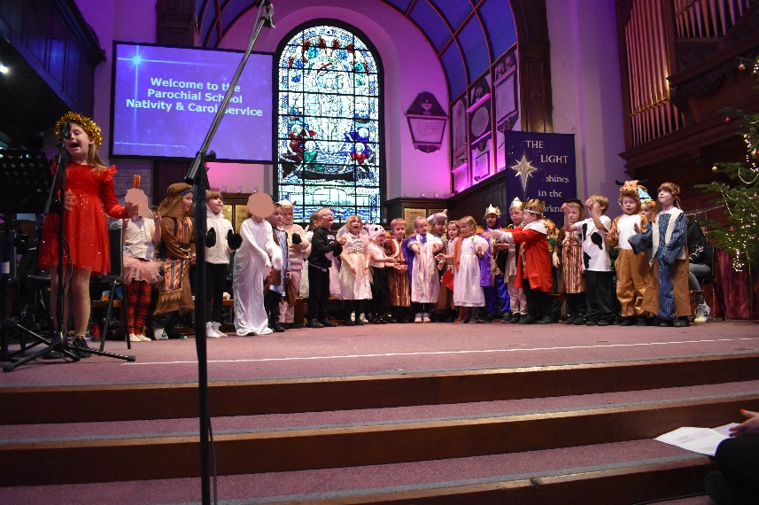

Dates for your diary:
Wednesday 17th December Christmas Lunch and Jumper Day.
Friday 19th December Last Day of Term.
Monday 5th January INSET Day
Tuesday 6th January 2026 Start of Term 3

