
Deal Parochial Church of England (Aided) Primary School

Mrs M Palmer BA Honours, PGCE, NPQH Gladstone Road
Headteacher Walmer, Deal
Tel: 01304 374464 Kent CT14 7ER
email: secretary@deal-parochial.kent.sch.uk Website: www.deal-parochial.kent.sch.uk

Christian values: - Kindness, Trust, Friendship, Respect, Courage, Forgiveness
TO BE THE BEST THAT I CAN BE – THE WAY GOD INTENDS


Newsletter 1 Term 2
In our collective worship last week, we have been reflecting about some of the proverbs and what we can learn from these. The children have been thinking about wisdom and to whom they can turn to for guidance.

Harvest Festival
The children led a thoughtful service at St. Leonards Church. It was an opportunity for us all to think about being thankful and generous towards others. The meaning of Harvest was conveyed through reading, prayers, reflection and song. It was wonderful to see so many parents attend the service as well. Many thanks for all of the food donations that came into school – Deal Foodbank were grateful for the donations.

School Disco
A big thank you to all of the parents who helped with this event and to all members of the PTFA who helped to organise the event. A special shout out to Mr. Matthews for organising the music and lights. The children had a really good time and did a lot of dancing and singing!

Curriculum news
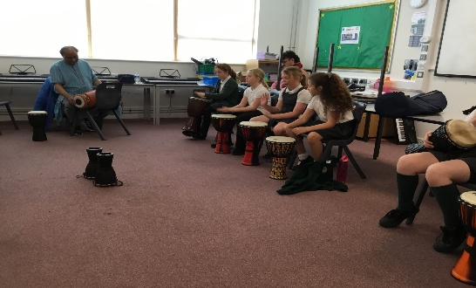
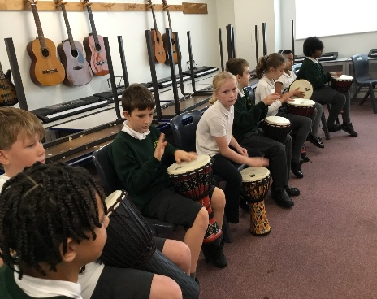
Just before half term, Year 5 were invited to a Dance Fusion event at Goodwin Academy. They took part in melody, drama, percussion and digital music workshops to explore South Indian dance and rhythm. Everyone had a fantastic day and enjoyed exploring their creative talents.

Parents’ Evening Week Beginning 10th November (sign up lists will go up the week before)

Just a reminder that it will soon be the first parents’ evening of the academic year and so please sign up to make an appointment with your child’s teacher and look out for the sign-up lists that will be put up this week.

Anti-Bullying week 10th - 14th November
We will be having an Odd Socks Day on Monday 10th November to start this off. This year’s theme is The Power of Good.

Tours available for Year R places in September 2026
Just a reminder that if you are looking for a Reception school place for your child in September then please book a place on one of our tours. Applications open on November 7th and close on January 15th 2026. For further information about the application process then visit
https://www.kent.gov.uk/education-and-children/schools/school-places/primary-school-places

Book Fair
Link : https://bookfairs.scholastic.co.uk/travelling-books/parents
Our annual Book Fair is arriving in school on Wednesday 12th November. This is a great opportunity to purchase books (maybe for Christmas!), and every purchase goes towards free books for our school.
The Fair will be open in the school hall during the parents evening on Wednesday 12th November, and then for the following times:
Thursday 13th November 3.20-4pm
Friday 14th November 3.15-4pm
Monday 17th November 3-3:30pm
LAST CHANCE!! Tuesday 18th November 8:40-9:15am
Please come and browse the new books this year, support the school and say hello



Dates for your diary:
W/C 10th November Parents Evenings – Sign up lists will be posted the week before.
Anti- Bullying Week 10th - 14th November The Power of Good. Monday 10th November is Odd Socks Day to celebrate that we are all unique and different.
Friday 14th November Children in Need
School Photos Monday 17th November
Friday 28th November Non - uniform day for Christmas Fair items Year R red and gold or Christmas themed; Year 1 and 2 – toiletries; Year 3 biscuits; Year 4 – chocolate; Year 5 and 6 bottles.
Friday 5th December Christmas Fair
Thursday 11th December Whole School to watch Sleeping Beauty pantomime at Goodwin Academy. Friday 12th December Nativity Service at St George’s Church at 1.45pm. Collection from the Church.
Tuesday 16th December KS2 to watch Robin Hood pantomime at The Astor Theatre.
Wednesday 17th December Christmas Lunch and Jumper Day.
Friday 19th December Last Day of Term.

