
Christian values: love, courage, hope, resilience, respect

TO BE THE BEST THAT I CAN BE – THE WAY GOD INTENDS
Collective Worship I Samuel 17

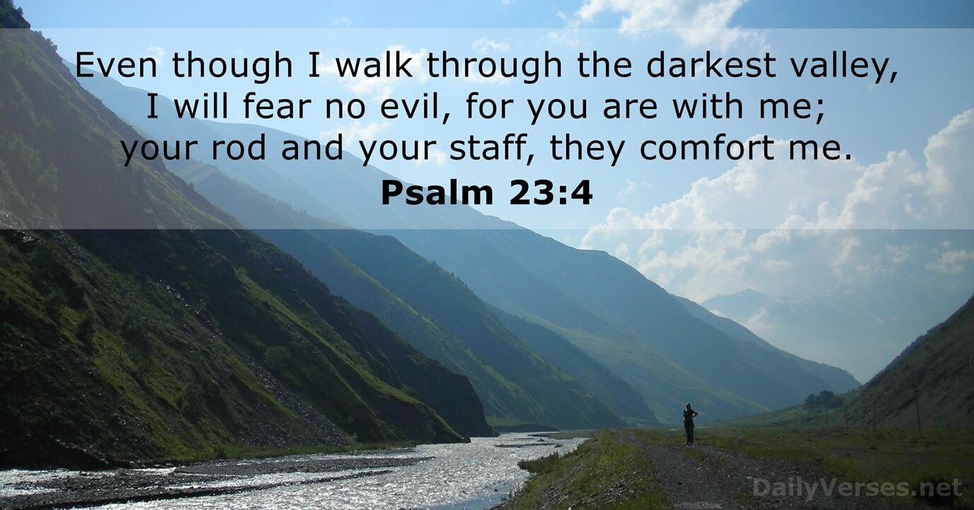
We have been reading the story of David and Goliath and learning about what it means to be courageous.

Our reviewed vision
We have worked together on tweaking our school vision statement so that it reflects our current vision and values to:
‘To be the best that I can be – the way God intends’
We are an inclusive and welcoming school family living and learning in the light of Jesus. Inspired by the Bible story of the Feeding of the 5000, we believe that we should share what we have with compassion and faith. Through the values of love, courage, hope, resilience and respect, we grow and flourish together.


Safety coming into school
We encourage children to ride and scoot to school but please can they get off their bikes and scooters and walk them into school and at the end of the day not ride them out of school. We have had a few near misses of late. Thanks for your co-operation in this matter.
Also, for pedestrian safety of children and adults please use the crossings carefully.

After School Club
From next term this will be available for working parents until 6pm for a charge of £9.50. This will include childcare from 3.15-6pm and a small meal at 5pm. The time slots for after school club are the following:
3.15-5pm £7.50 (includes a snack)
3.15-6pm £9.50 (includes a hot meal)
This will all be bookable in advance via the school money app. Please book in advance so that we can plan staffing appropriately.
Please also ensure that if you use the afterschool club facility that you pick your child up on time otherwise there will be a charge of up to £10 extra. Many thanks for your understanding.

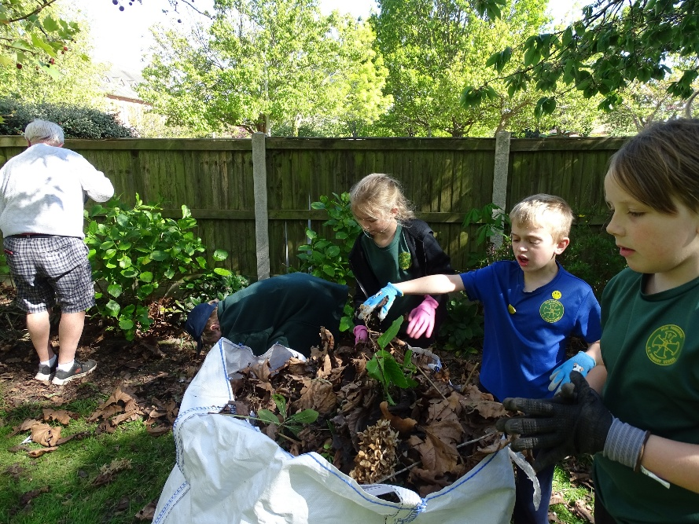
Spiritual Garden
Work is underway to rejuvenate our spiritual garden. Gardening Club have been working with some members of St. George’s church to de-weed, clear leaves, tidy and sort. A transformation is happening already. A big thank you to St. Georges for all the support that they have provided so far and to all the children for their hard work.

PTFA Events
Film night Years 3 and 4 took place last Wednesday. Many thanks to Michelle Pickering and all the PTFA members for their support.
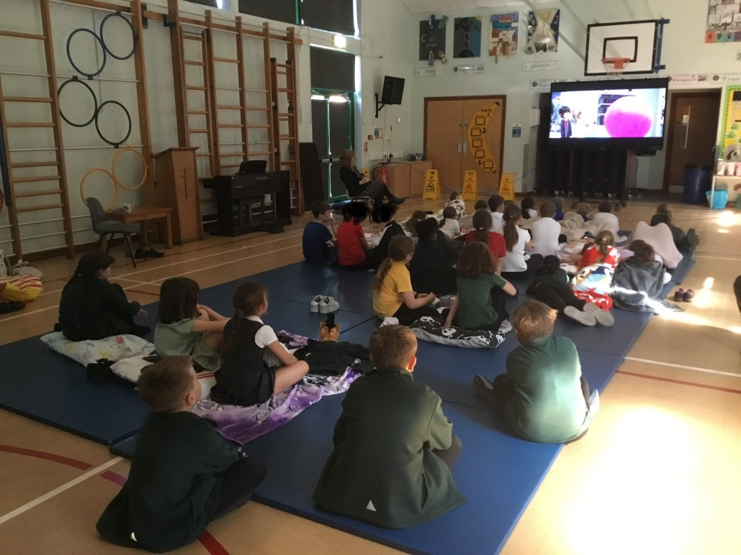

PTFA Events coming up:
Film night Year 5 and Year 6 will be held on Wednesday, 20th May at 3.15-5.15pm
Summer Fair - Friday, 3rd July 2026 from 2.30pm

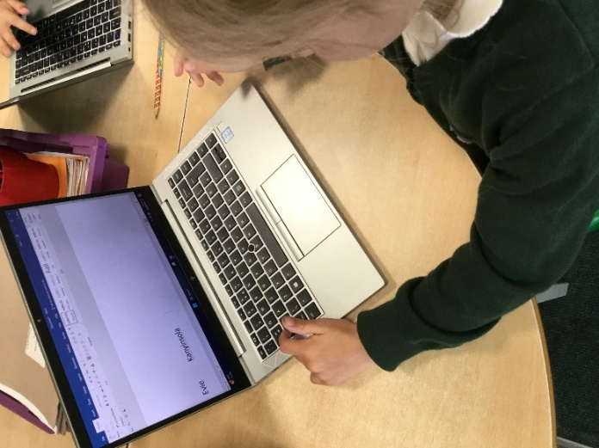
Curriculum News
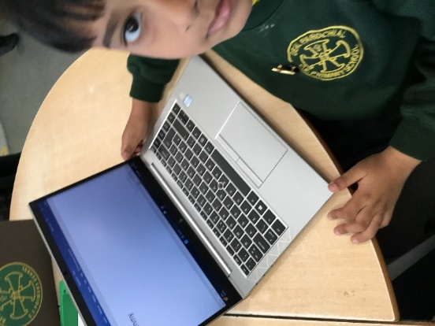
Year 1 have been on a digital adventure, exploring how to use Word like real authors. They’ve been hunting for letters on the keyboard, practising capital letters, adding perfect word spaces and learning the magic trick of starting a brand-new line. They’re well on their way to becoming confident young writers.

We are becoming a cashless school
Just a reminder that all clubs should be paid for in advance including breakfast and after school provision via School Money. We cannot take bookings on the day for after school club unless there is an emergency. This is so that we can ensure that we are adequately equipped with staff for the number of pupils we have.
99% Attendance on the first week of term!!
This is an amazing achievement and the whole school had extra play last Friday. Please do remember that school gates open at 8.30am for an 8.40am start so that the school day starts promptly. Every second, every minute counts of learning.

Dates for your diaries:
Wednesday 6th May - Year 6 St. Mary’s Church for Collective worship across DEALT schools
Monday 11th to Thursday 14th May - SATS Assessments Year 6
Monday 18th May - Class Photos
Tuesday 19th May - Welcome Evening for EYFS September 2026 intake 5-6pm
Wednesday 20th May - Film night Year 5 and Year 6, 3.15-5.15pm
Friday 22nd May - Last day of term 5
Monday 1st June - First day of term 6

