
Christian values: love, courage, hope, resilience, respect

TO BE THE BEST THAT I CAN BE – THE WAY GOD INTENDS
Collective Worship Genesis 8: 6-13
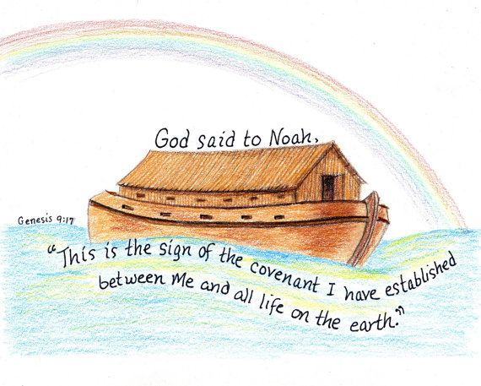
In worship this week, we have been learning about the story of Noah and the Ark. Noah finds that he has to see how the plan would work out. We have been thinking about how sometimes in life we have to be patient and that it takes patience to create something amazing.

Year 6 SATS
Our Year 6 children have made us incredibly proud. Throughout last week’s SATs, they showed real resilience, courage and determination. Every single day they arrived ready to give their very best, and they worked so hard. We couldn’t have asked for more from them. Well done, Year 6!
Year 4 Floristry 14th May
Research from Natural England highlights that engaging with nature can boost children’s wellbeing, confidence and social development. In response, Barratt David Wilson Kent organised a Spring themed floristry workshop for Year 4 pupils at Deal Parochial Primary School in partnership with Contemporary Flowers, close to its Sholden Meadows development.
Hosted by Rachel from Contemporary Flowers, the interactive session introduced pupils to the art of floristry. The pupils were taught how to make their very own sunflower boxes, which they were able to take home. The workshop encouraged the pupils to engage with nature in a hands on and creative way whilst developing teamwork, confidence and practical skills outside of the traditional classroom environment.
Rachel from Contemporary Flowers commented: “It was wonderful to work with the Year 4 pupils at Deal Parochial Primary School alongside Barratt David Wilson Kent. Floristry offers a creative and engaging way for children to connect with nature while developing new practical skills, and it was fantastic to see how enthusiastic and involved the pupils were throughout the session.”
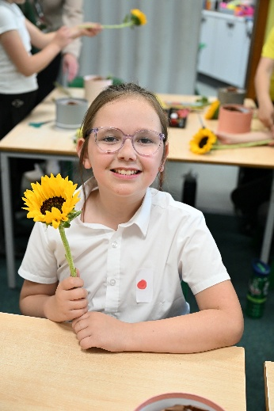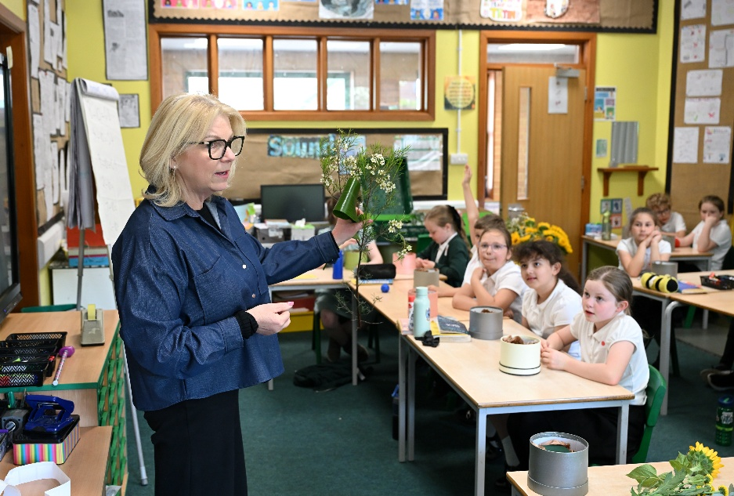

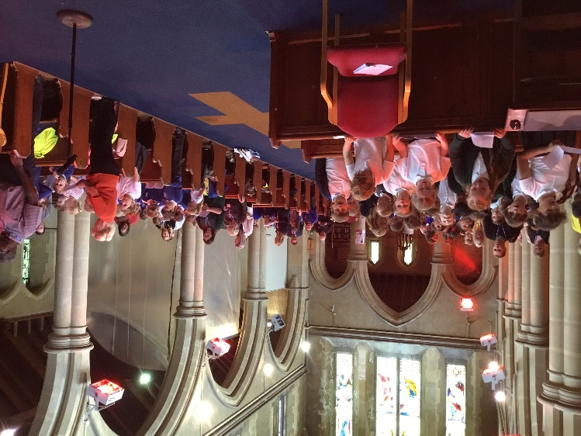
DEALT worship at St. Mary’s Church
Our Year 4 children led a part of the collective worship at St. Mary’s church on 6th May. The children introduced the service and explained what Justice is and what it feels like when there is an injustice. The children did this by leading a drama scene. They spoke so clearly and had evidently spent time learning lines. Well done children!

New Vicar at St. George’s Church
We warmly welcome Reverend Sean Sheffield who is the new incumbent at St. Georges Church. He came in to meet the children on Monday and we look forward to working with him in the future.

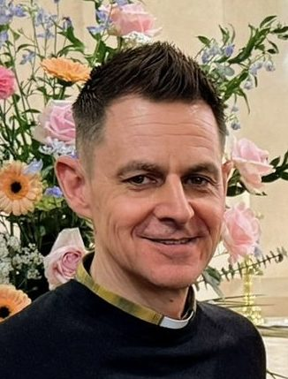

PTFA Events coming up:
Film Night Years 5 and 6, Wednesday, 20th May 3.15-5.15pm
Summer Fair, Friday, 3rd July 2026 from 2.30pm

Year 5 Pizza Express
On Wednesday 13th May, Year 5 went to Pizza Express in Canterbury to make pizzas. The children learnt how to shape the dough to be the right size (which was very tricky!) before topping with the amount of tomato sauce and cheese that they wanted. While the pizza chef was cooking them, they were able to sample some of the most common toppings. Fresh basil and green pepper were popular; black olives less so! They were then able to eat their pizzas in the restaurant garden before heading off to The Beaney Museum to look at some of the exhibits.
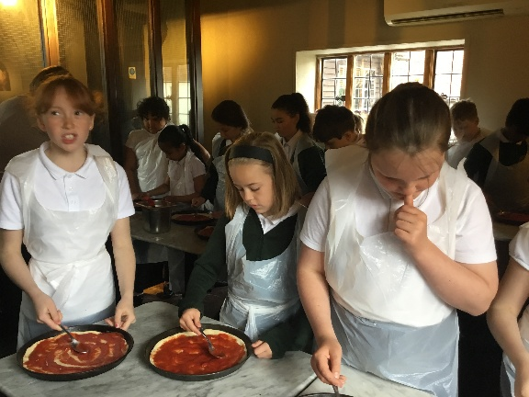
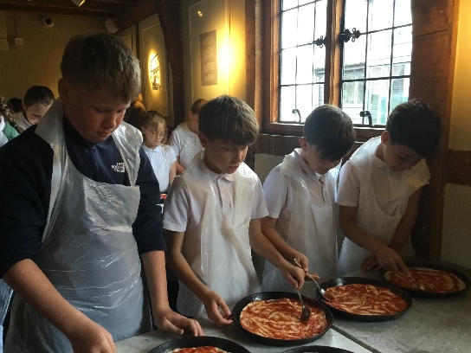

Dates for your diaries:
Tuesday 19th May - Welcome Evening for EYFS 5-6pm
Wednesday 20th May - Film Night Years 5 and 6, 3.15-5.15pm
Friday 22nd May - Last day of term 5
Monday 1st June - First day of term 6
Thursday 25th June - Sports Day (EYFS and KS1 12.45pm; KS2 2.00pm)
Friday 3rd July 2.30pm – Summer Fair

