Deal Parochial Church of England (Aided) Primary
School


Newsletter 3 Term 6
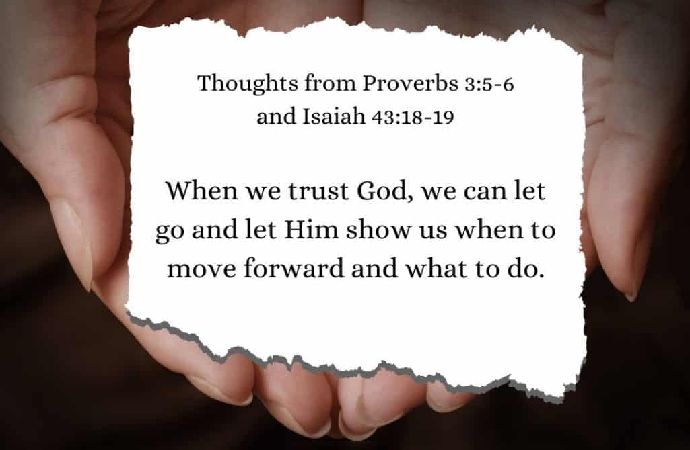
In worship, we have been thinking about courage and how God supports us as we move into new schools and new year groups. We have spent time sharing our achievements and reflecting on the moments when we have felt truly proud of all we have accomplished.
Summer Fair Success
Thank you for your support for this event. We raised £1789 altogether which will go a long way in supporting the school to improve resources. The children would like some updated playground markings/ games on the playground and this will help this happen. A big thank you to the PTFA and all of the staff that supported the event. A special shout out to Michelle Pickering our PTFA chair who has worked tirelessly to support the event.
Treasure Island
Splat Pantomimes came to the school to perform Treasure Island. This was also partly funded by the PTFA as an end of term treat. The children were thoroughly engrossed throughout and thoroughly enjoyed the performance. They were a super audience and really got into the spirit of the performance cheering, gasping and laughing all the way!
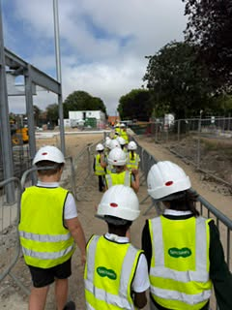
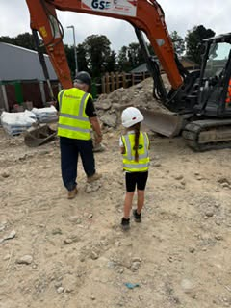
Deal Parochial takes part in a special Time Capsule Ceremony
Our Year 3 children went to the new Tides complex to bury three of their own time capsules for the future. They filled the capsules with special memories and letters for the future. After the ceremony, the children were treated to an exclusive behind the scenes tour of the construction site where they were able to ask questions and see engineering in action.
We would like to thank the Council and the team at the new Tides Complex for inviting us to take part.

Year 6 The Accidental Time Travellers!
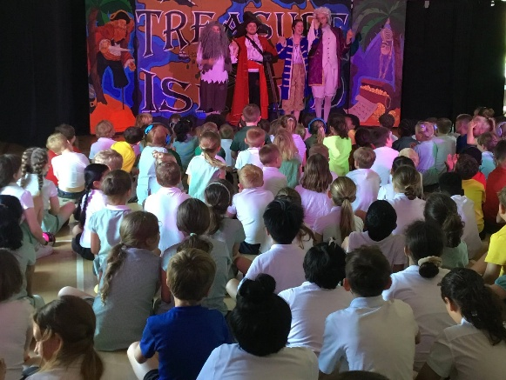
What an amazing performance! The children entertained the whole school and then their parents with an incredible end of Year 6 production. The children took us back in time with some songs, laughter and fabulous acting. Well done Year 6 what a talented bunch you all are - we hope that you continue to seek out opportunities to be on the stage in the future. A special thank you to Mrs. Watson and her team for putting the production together.

Saying Goodbye
We wish Mrs Johnson every happiness as she begins her new adventure into retirement. Her many years of dedicated service, along with her enthusiasm and determination to bring out the best in every child, will be greatly missed.
We also say goodbye to Mrs. Katie Benbow as our Chair of Governors, thank you so much for the support and commitment that you have given the school over the last year.
Year 6 Good Luck and Fare well
Our wonderful Year 6 pupils are now ready to begin an exciting new chapter. We are incredibly proud of everything they have achieved during their time at our school and grateful for all they have contributed to our community. Their leadership, kindness and hard work have made a lasting difference. They are more than ready for the challenges and opportunities that await them, and we know they will continue to shine.
Headteacher message
As we reach the end of a successful year, I want to extend my heartfelt thanks to all our families for your continued support. Together, we have achieved so much, and our children have flourished in every corner of school life.
A special thank you goes to our Year 6 parents. Your partnership, encouragement and commitment have helped shape the confident, capable young people who are now ready for their next chapter. We wish you and your children every happiness and success as they move on.
My sincere thanks also to our dedicated staff and governors, whose hard work, care and unwavering commitment ensure our school remains a place where every child can thrive.
I wish all our families a wonderful summer break and look forward to continuing our journey together in September.

We look forward to seeing all of our children for the start of the Autumn Term on Wednesday September 2nd. Have an enjoyable summer holiday!

